FIRST START-UP OPERATIONS

- Assure there is an air source connected to the pump, and that the inlet of the pump is plumbed with tubing to a refill reservoir, and that the outlet of the pump is plumbed to an open reservoir or back to the refill vessel; at this time, we do not want to plumb the outlet of the pump to the test apparatus, UNLESS we have a method of diverting the outlet flow of the pump to an open reservoir. Turn the pump(s) on via the switch on the AC inlet. The two digit LED display on the front of the pump (or on the front of the pump controller) will cycle through a start up sequence for about a minute and then flash “d0”.

- Launch PumpWorks on your computer.

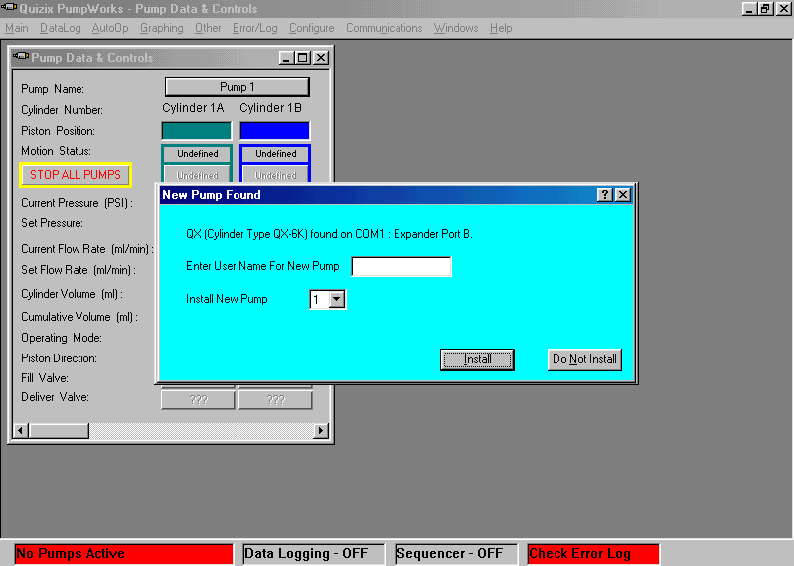
Figure 1 Starting PumpWorks software

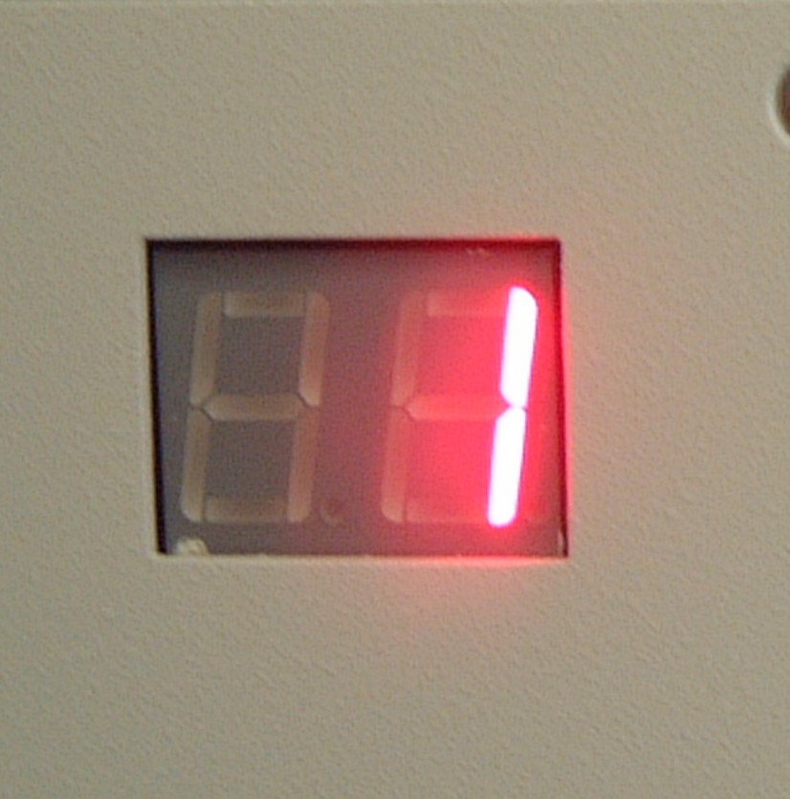
PumpWorks will automatically search for the serial expander and then for a connected pump. After about a minute, PumpWorks should inform you that a new pump has been found. Click the “Install” button as shown I Figure 1. The Pump Data and Control window in PumpWorks will fill in with information and the two digit display on the pump controller will change to a flashing “_1” (indicating this is the first pump installed.) The “_1” will continue alternating with “d0” until the safety pressure is set.

NOTE: If more than one pump is being installed, subsequent pumps will flash “_2”, “_3”, and so on indicating the position each pump is installed at.

- When “d0” is being displayed, PumpWorks will require you to enter safety pressures for the pump and a dialog box will appear. Enter appropriate safety pressures for all cylinders and click on the “Send Safety Pressures to Pumps” button.
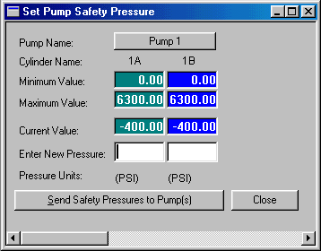
Figure 2- Safety pressure settings window

Each pump type has a maximum pressure it will support, but the user should set a lower safety pressure if other components in the flow system can not support the pump’s maximum pressure rating. Generally, safety pressures should be set according to one or more of the following criteria:
- Maximum pressure capability of the test apparatus.
- Maximum pressure the sample matrix should be exposed to
- In core flooding and formation test systems, consideration should be given to limiting the safety pressure to the same value or slightly lower pressure value of the confining pressure set point
- Assuring the maximum pressure differential between actual operating pressure and any other system constraints. This assures adequate headroom between actual operating pressure and the safety pressure set point to prevent inadvertent shutdown of the pump(s) should the pressure in the pump exhibit a momentary increase.

NOTE: When installing multiple pumps, occasionally pumps will install in wrong positions, i.e. Pump 1 should really be Pump 2 or 3, and so on. To change the pump position within PumpWorks software, go to the CONFIGURE tab, select “Reassign Pump Number”, and move the pump to the correct position.

PRIMING THE PUMP

- Before starting the pump, you need to prime the pump (i.e. get fluid into the pump’s cylinders.) On the main Pump Data and Control window, click on the “Operating Mode” button for Pump 1 Cylinder A; this will bring up the dialog box with the pump operating modes. Select Mode 1C “Individual Constant Rate-Cycled”. Click on the “Set Flow Rate” button and set any desired flow rate up to the maximum indicated.

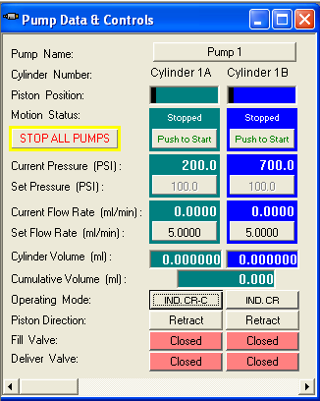

Figure 3 Pump Data and Control Window

- Assure all valves for both cylinders are CLOSED. You can click on the Fill Valve and Deliver Valve buttons located on the bottom of the Pump Data and Control window to toggle the valves open or closed.

- Now you can start Cylinder 1A in motion by clicking the button marked “Push to Start”. The pump will automatically open/close the deliver and fill valves for Cylinder 1A as appropriate and begin to automatically fill itself. Allow the pump to run for two to ten piston strokes to remove the air from the cylinder. Once you can no longer see air bubbles exiting the outlet line, the cylinder is full of fluid. Stop the cylinder with piston in the fully retracted position.

- Now you need do the same steps to Cylinder 1B. It is recommended that we fill/purge only one cylinder at a time. If multiple pumps are connected, you can fill/purge multiple pumps at the same time, as long as we only fill one cylinder from each pump at a time. .

ZERO PRESSURE TRANSDUCERS AND SET COFIGURATIONS

- After filling both cylinders, leave the fill valves open. If the fill valves are closed, you can open them by clicking on the Fill Valve button located on the Pump Data and Control Window near the bottom of the window. The pressure transducers are calibrated at the factory, but the initial value for ambient pressure may be different. You can set the initial value of the pressure transducers at this time by clicking on the “Other” item on the main menu and then selecting “Software Pressure Transducer Calibration”. The dialog box shown in Figure 4 will show the current pressure value for each transducer, as well as the Current Offset gain (zero gain) and Current Gain (high span gain). Since the Fill Valves are open, the Current Pressure value should be at or near ambient, and can be set to zero by clicking the “Current Offset” button and selecting “Auto Zeroing” button. If you have a version of PumpWorks software greater than 6.02, you can click the check-boxes for “cylinders to change”, and then click the “Auto-Zero All Checked Cylinders”. Do not change Current Gain, as this is the factory span calibration factor.

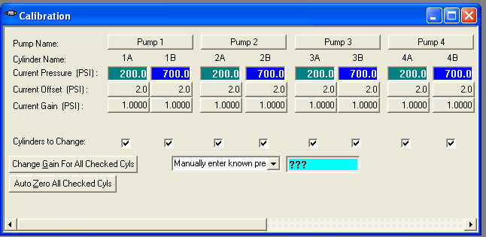
Figure 4 Pressure Transducer Auto Zero Calibration

- Now go to the CONFIGURE tab, and select “Pump Operating Parameters”. A window should open as in Figure 5. Criteria for setting the configuration parameters are as follows:

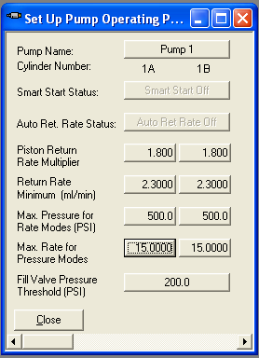
Figure 5 example of operating parameter window

NOTE: settings shown in Figure 5 are specific to a QX-500 pump module; settings for Max Pressure for Rate Mode and Max Rate for Pressure Mode will be different than shown for other Quizix pump models.

Smart Start Status = ON
The Smart Start feature should ALWAYS be ON. This allows the pump to select which is cylinder is best suited to begin operations. If this feature is turned OFF, then the user is responsible for starting the correct cylinder that is best positioned to run. IF A CYLINDER IS MANUALLY SELECTED TO START THAT IS NOT IN PROPER PISTON POSITON, IT IS PROBABLE THE PUMP WILL NOT OPERATE CORRECTLY!

Auto Return Rate Status = OFF or ON
With the Auto Return Rate turned ON, this feature allows the pump to automatically refill at maximum rate (typically 3X the maximum flow rate of the pump). When the Auto Return Rate is turned OFF, it allows the user to set the return rate (refill rate) at a lower speed. Considerations should be given to the viscosity of the fluid, length of tubing from the pump to the refill reservoir, and any possible flow restrictions such as those that might be caused by external valves between the pump and the refill reservoir, or the use of a filter on the inlet line. A safe bet is turn the Auto Return Rate feature OFF, and use the Return Rate Multiplier function to determine refill rates.

Piston Return Rate Multiplier = 1.8 or other value
The Piston Return Rate Multiplier provides a way for the user to slow down the refill speed of the pump to match fluid or environmental conditions that might impact the pumps ability to properly refill without cavitation (sucking air into the cylinder). This feature is only available when the Auto Return Rate Status is OFF. The Return Rate Multiplier is a value that is multiplied by the actual pump flow rate to determine refill rate. We need to set a multiplier value that will allow the pump adequate time to refill the cylinder completely full of fluid, AND pre-pressurize to the operating pressure BEFORE the cylinders have to switch. Typical settings for aqueous-based fluids is 1.8. If your fluid is slightly viscous, or you have potential restrictions in the inlet lines, you may need to reduce this value. DO NOT set a value lower than 1.2 or 1.3 or you will run the risk of not having enough time to pre-pressurize before cylinder switchover. Setting a value too low for your flow rate will cause the pump to exhibit pressure spikes at switchover!

Return Rate Minimum = 2.5 ml/minute
The Return Rate Minimum feature provides a method of assuring the pump does not refill too slowly, or assures that the pump refills with adequate time to pre-pressurize before cylinder switchover. Typical value is 2.5 ml/minute. This value will override the Return Rate Multiplier value discussed above, and as mentioned, setting this value too low will cause pressure spikes at cylinder switchover.

Max Pressure for Rate Modes = user-settable value
The Max Pressure for Flow Rate is the preferred method for limiting pump pressure due to environmental conditions. When the Max Pressure setting is reached, it forces the pump to stop operating in Constant Flow Mode, and switches to Constant Pressure Mode. This prevents the pump from reaching the Safety Pressure shut-down limit while allowing the pump to continue operating. Once the pressure restriction is relieved (either manually or due to environmental conditions), the pump will switch back to Constant Flow operations. Error messages will be generated in the Error Log so the user knows an event has taken place. Typical settings for this value would be equal to the maximum pressure the user wants to expose the sample to, or slightly less than the confining pressure (for a core flood rig).

Max Rate for Pressure Modes = factory default is max pump flow rate
This feature is similar to the Max Pressure for Rate feature described above, but is only functional when the pump in operated in pressure control modes. Primarily, it is used to reduce the speed of the pump as it attempts to maintain or ramp up to pressure. Typical settings are for this value to be at the maximum flow speed of the pump.

Fill Valve Pressure Threshold = 200
This feature prevents the pump from opening a Fill Valve when the pressure in the cylinder is excessively high. When using a refill reservoir at ambient pressure conditions, set this value to 200 psi. For operations that require pressurized refilling, set this value to a pressure slightly less than operating pressure, but higher than the refill pressure. 200 psi is the lowest value that can be set.

PUMP PRESSURE SERVO CONTROL GAINS

- PumpWorks allows the user to set proportional and differential pressure servo gains. Of most importance is correct Closed Valve gain settings; this assures the pump correctly matches cylinder pressures before switchover without excessive overshoot or undershoot. Open Valve gains are provided to assure the pump reacts correctly to larger system volumes when operated in pressure control modes. Essentially, proportional gain is like stepping on the gas in your car; a higher value will cause the pump to react quicker to reach a pressure. Differential gain is like stepping on the brake; this will dampen (or reduce the rate of change) once the pressure is close to the target. See the PumpWorks manual for complete discussion on this feature. Typical values for Closed Valve gains are 2000 and 2000. Check these values before operating the pump is assure

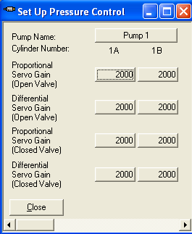
Figure 6 Pressure Servo control Window

RESETTING CYLINDER VOLUMES TO ZERO

- Now we need to reset our cylinder volumes to zero. Click the MAIN tab, and select “Reset Volumes to Zero”. You can select individual cylinder volumes or cumulative volume, or click “Reset All Volumes to Zero”. Resetting the cylinder and cumulative volumes to zero provides the user with a distinct starting point for volume calculations, and is typically done once the pump is primed and both cylinders are in the correct position for running the necessary mode of operation.

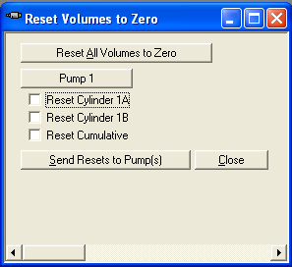
Figure 7 Reset Volumes to Zero window

PUMP SET UP FOR DUAL CYLINDER DELIVER MODES (flow or pressure)

- Assure the piston positions for any pump operating in Paired Constant Rate-Deliver or Paired Constant Pressure-Deliver are fully retracted. See Figure 8A, and look at the graphical piston position bar located at the top of the Pump Data and Control window for Pump 1 for an example of proper piston position for any pump that is operated in “Deliver: modes. Click on the “Operating Mode” button, and select Mode 6 “Paired Constant Rate”, or Mode 8 “Paired Constant Pressure”. Click on “Set Flow Rate” (to set a flow rate) or “Set Pressure” (to set a pressure set point) to select the desired set point. Click “Push to Start” and the pump will begin continuously pumping fluid at the selected rate or pressure. The pump will automatically control the valves in Paired-Deliver modes.

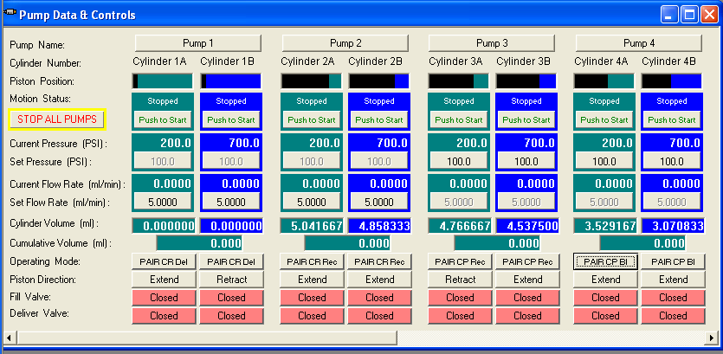
Figure 8A, Pump 1 Piston Position for Deliver Modes

PUMP SET UP FOR DUAL CYLINDER RECEIVE MODES (flow or pressure)

- Paired Receive Modes are used ONLY for pumps that will be required to receive fluids (NOT deliver fluids) from a teat apparatus. Pumps that will operate in Paired Constant Flow-Receive or Paired Constant Pressure-Receive modes should have their pistons started at 75% extended. See Figure 8B, and look at the graphical piston position bar located at the top of the Pump Data and Control window for pump 2 (Constant Rate Receive) and pump 3 (Constant Pressure Receive) for examples of proper piston position for these modes.
  - To manipulate pistons into the correct position, click on the Operating Mode button, and select Mode 1, Independent Constant Rate mode.
  - Enter a flow rate of 50% of pump maximum.
  - Open the FILL valve by clicking the FILL VALVE button located under each cylinder (this assumes the refill reservoir is under ambient conditions).
  - Click the Push to Start button for each cylinder, and allow the piston to extend until it reaches approximately 75% of its travel, and stop the cylinders.

Figure 8B, Pump 2 and 3 Piston Positions for Receive Modes

- Click the Operating Mode button, and select Mode 7 for Constant Rate-Receive or Mode 9 for Constant Pressure-Receive.
- Enter the appropriate flow or pressure set point, and click “Push to Start” button. The pump will now begin continuously receiving fluids, and the pump will automatically control valve action.

NOTE: In Constant Pressure-Receive mode, the pump will first extend the cylinders to reach the pressure set point; this is normal. Once the pressure set point is reached, the pump will automatically begin receiving fluids at the desired pressure set point.

PUMP SET UP FOR DUAL CYLINDER BI-DIRECTIONAL MODE (pressure)

- Bi-directional mode is used when the application requires that the pump be capable of delivering AND receiving fluids at a pressure set point. Pumps operated in Bi-Directional Pressure Mode should have their pistons set at 50% extended position for correct start-up. See Figure 8C, and look at the graphical piston position bar located at the top of the Pump Data and Control window for pump 4 (Bi-Directional Mode) for an example of proper piston position for this mode.
  - To manipulate pistons into the correct position, click on the Operating Mode button, and select Mode 1, Independent Constant Rate mode.
  - Enter a flow rate of 50% of pump maximum.
  - Open the FILL valve by clicking the FILL VALVE button located under each cylinder.
  - Click the Push to Start button for each cylinder, and allow the piston to extend until it reaches approximately 50% of its travel, and stop the cylinder.
- Click the Operating Mode button, and select Mode 12, Paired Constant Pressure Bi-Directional Mode. Enter a pressure set point, and click the Push to Start button.

Figure 6C, Pump 4 Piston Position for Bi-Directional Mode

NOTE: In Constant Pressure Bi-Directional mode, the pump will first extend the cylinders to reach the pressure set point; this is normal. Once the pressure set point is reached, the pump will automatically begin receiving fluids at the desired pressure set point.

